ROUTER CONFIGURATION

CISCO PACKET TRACER:
CONSOLE CABLE CONNECTION BETWEEN ROUTER AND PC
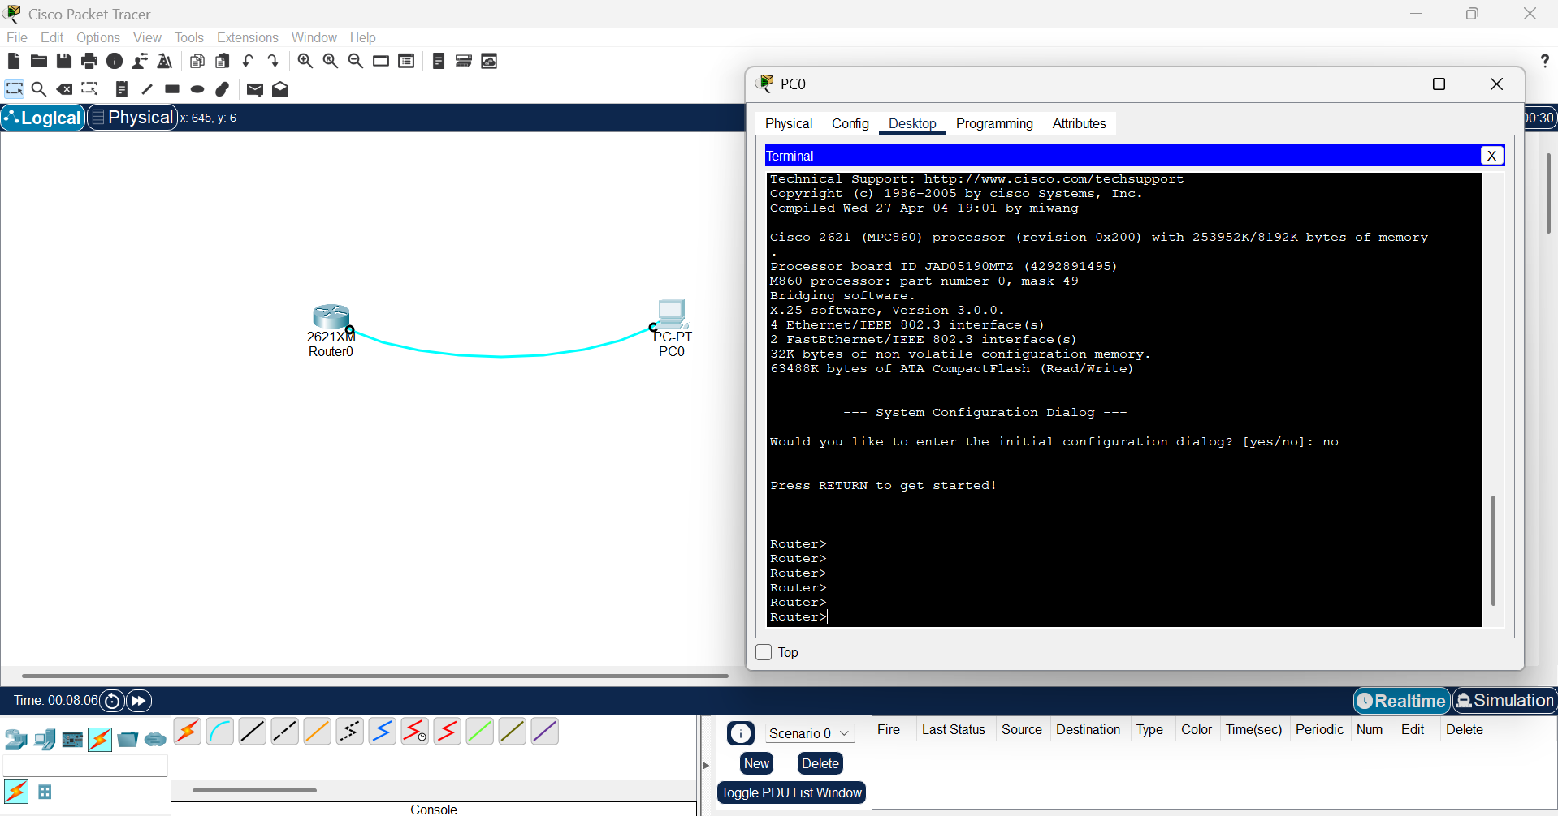

CONFIGURATING THE ROUTER AND CONNECTING THE UTP CABLE:
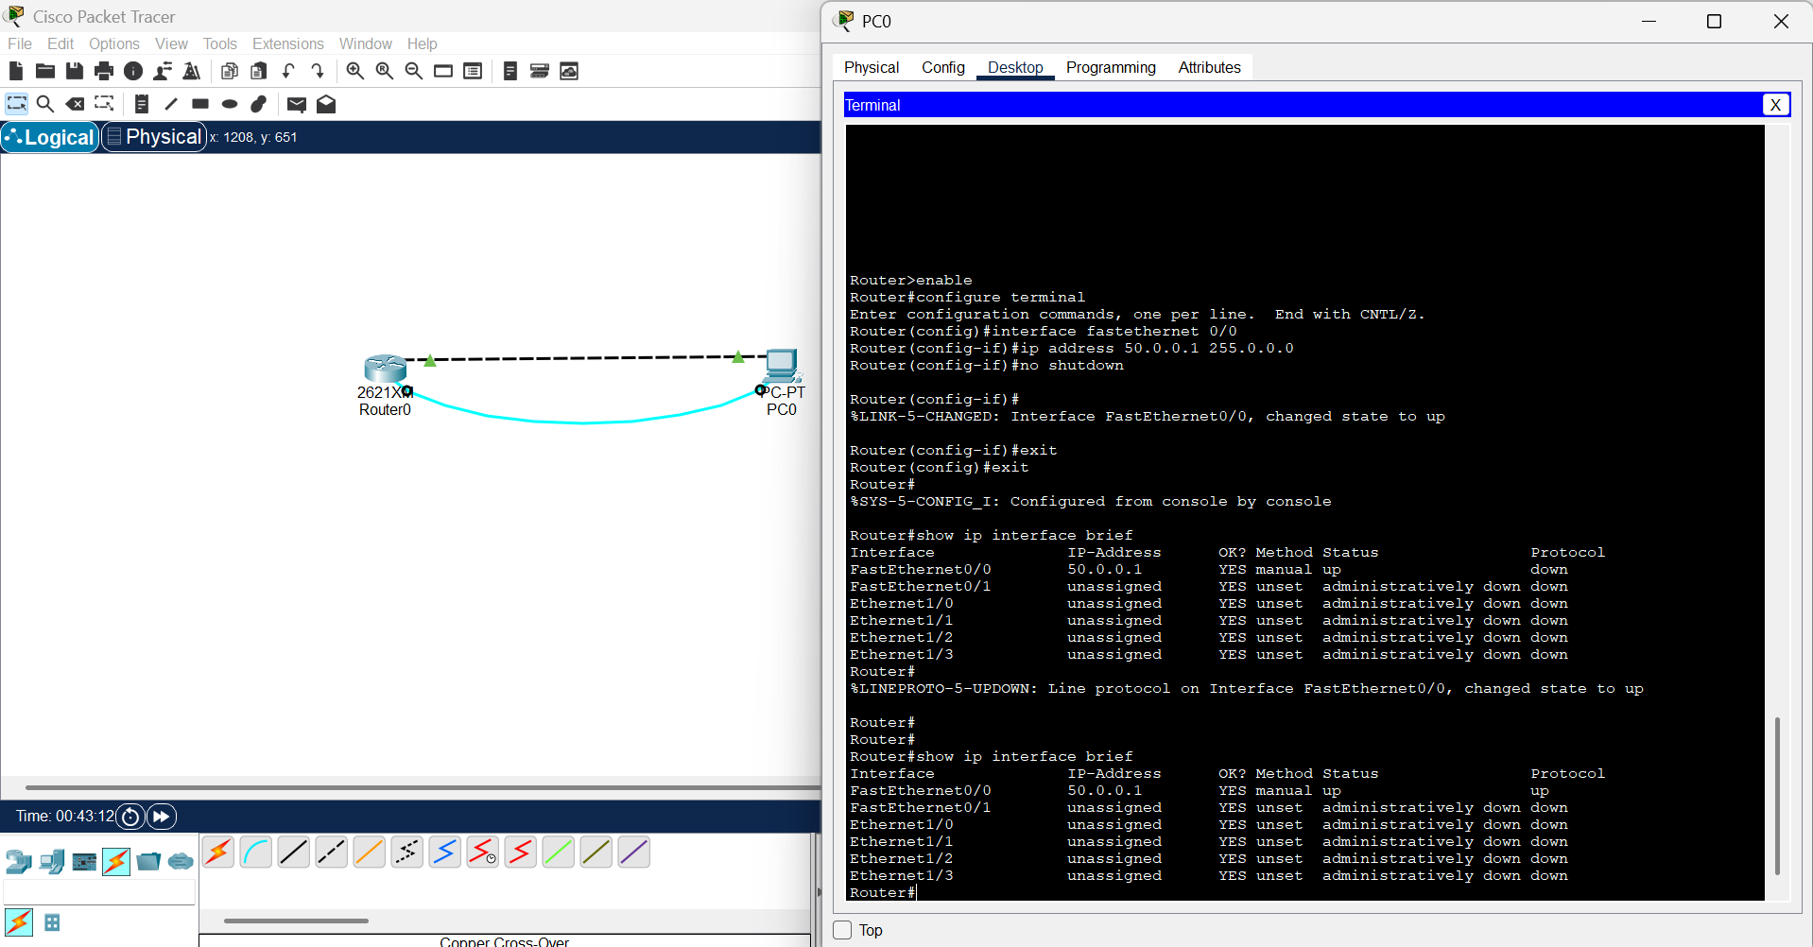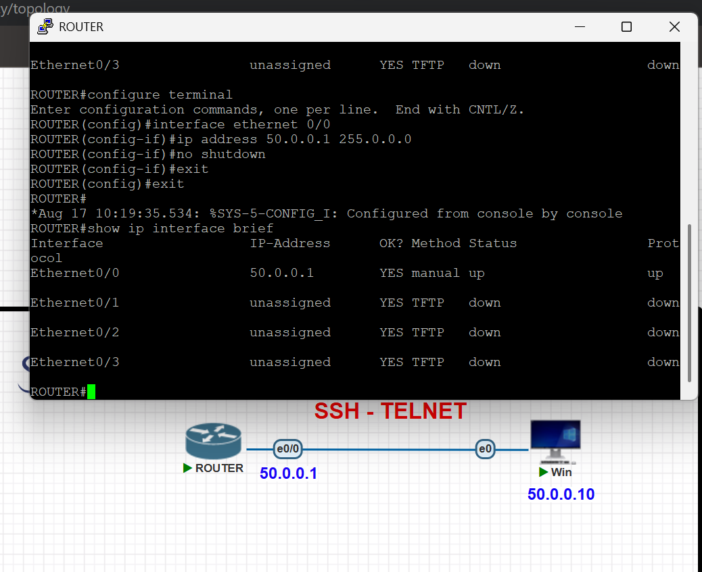

AUTHENTICATION COMMANDS USING LOGIN LOCAL:
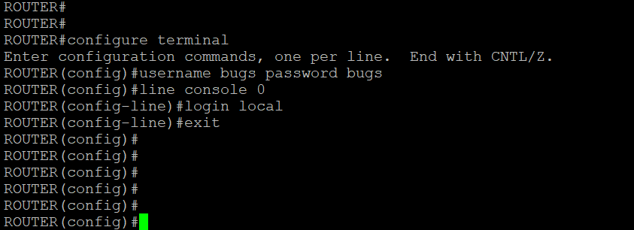
OUTPUT:
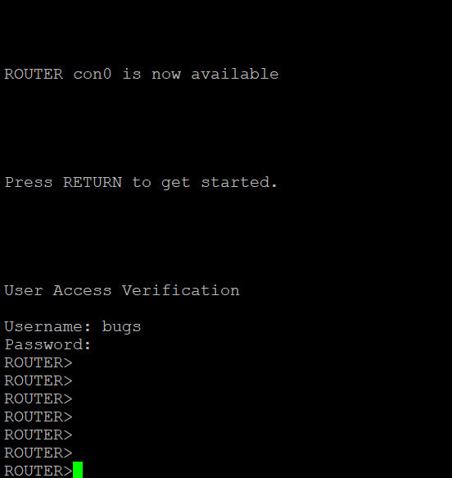
AUTHENTICATION COMMANDS USING LOGIN
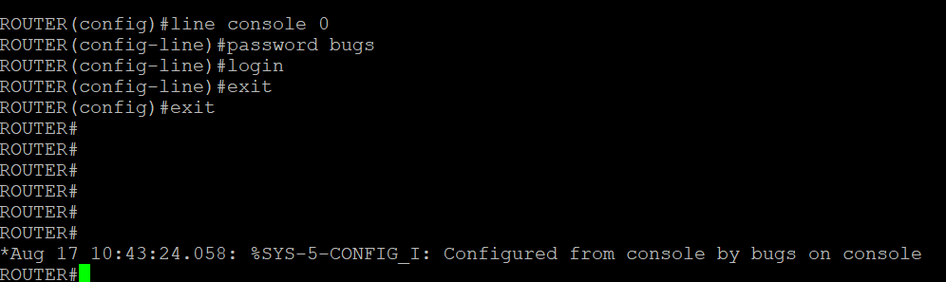
OUTPUT
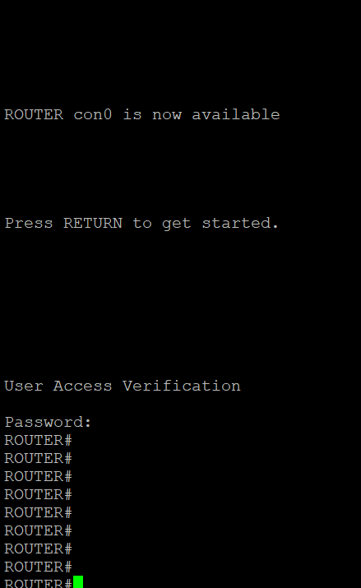

LEVEL WISE AUTHENTICATION
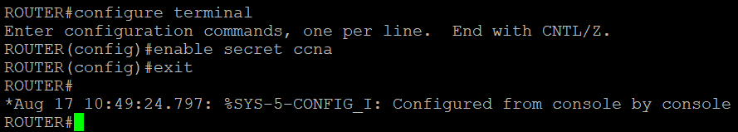
TELNET:
CHECKING THE NETWORK REACHABILITY FROM PC
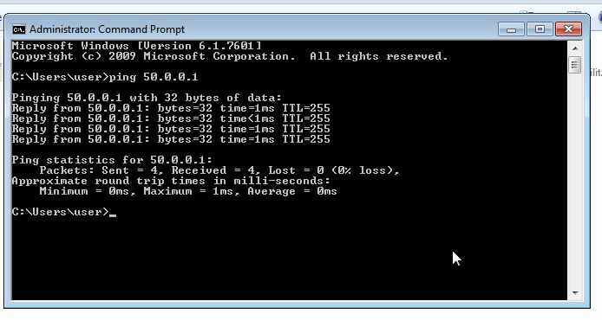
COMMANDS FOR TAKING THE ROUTER REMOTELY
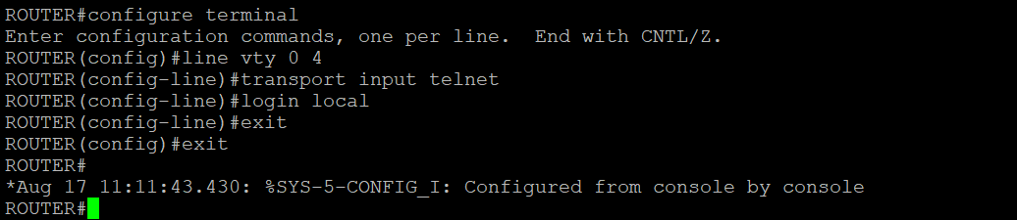
OUTPUT
